Proposed Title : A One Health–Based Assessment of Antimicrobial Resistance in Wastewater from Tier-2 Urban Settings in India
Synopsis
Antimicrobial resistance (AMR) has emerged as a critical global health challenge, increasingly recognized as a One Health problem involving interconnected human, animal, and environmental systems. Wastewater represents a unique environmental matrix that integrates antimicrobial resistance signals from entire urban populations, including households, healthcare facilities, and associated waste streams. In India, Tier-2 cities constitute an under-studied yet epidemiologically significant setting due to mixed land use, incomplete wastewater infrastructure, and partial segregation of medical and municipal waste.
This study proposes a bioinformatics-driven, wastewater-based analysis to examine how medical waste influences antimicrobial resistance gene (ARG) patterns in urban wastewater of Tier-2 Indian cities. Using publicly available metagenomic datasets, the study will comparatively assess antibiotic resistance profile of medical-influenced and non-medical wastewater. The work is framed explicitly as an ecological and population-level analysis, avoiding clinical, causal, or transmission-level inference. A reproducible analytical and visualization framework will be developed to support responsible interpretation of wastewater-based AMR data within a One Health context.
Introduction
Antimicrobial resistance threatens the effectiveness of antibiotics essential for modern medicine. Beyond clinical settings, the environment has been increasingly recognized as a critical reservoir and transmission interface for resistant bacteria and resistance genes. Wastewater systems, in particular, aggregate antimicrobial residues, resistant microorganisms, and mobile genetic elements originating from human populations, healthcare facilities, and urban activities.
International One Health frameworks emphasize the need to integrate environmental surveillance into AMR monitoring strategies. Policy documents such as the Quadripartite One Health Joint Plan of Action (2022–2026) highlight wastewater surveillance as a priority area for understanding and mitigating AMR risks. Despite this recognition, environmental AMR
surveillance remains limited in many low- and middle-income countries, including India.Tier-2 Indian cities present distinct challenges: heterogeneous sewage networks, variable treatment coverage, and frequent co-mixing of medical and municipal waste. These conditions create environments where antimicrobial resistance determinants may persist and circulate. However, most existing AMR studies in India remain clinically focused, leaving environmental contributions poorly characterized. This study addresses this gap by applying wastewater-based metagenomic analysis to investigate AMR patterns associated with medical waste influence in Tier-2 urban settings.
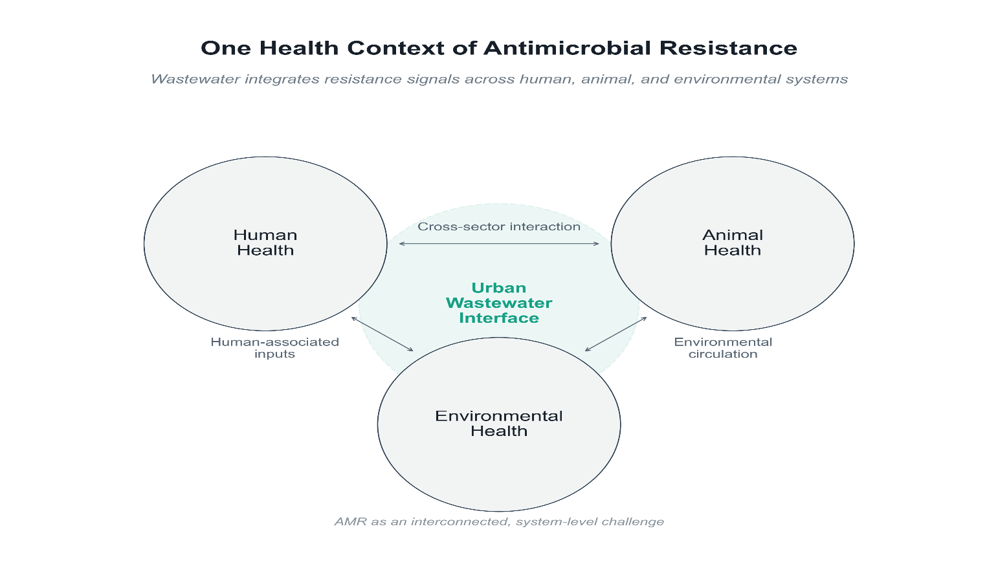
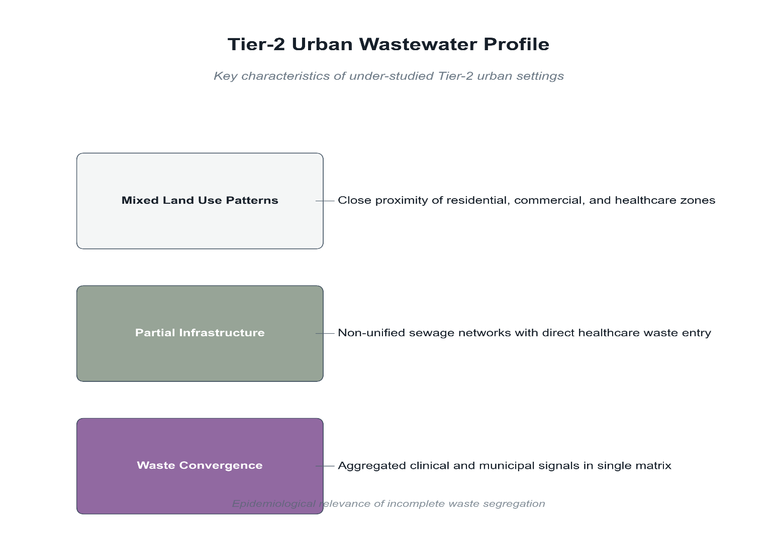
Literature Review
Recent literature recognizes antimicrobial resistance (AMR) as a One Health challenge requiring integration of human, environmental, and infrastructural data. The Quadripartite One Health Joint Plan of Action (2022–2026) emphasizes wastewater as a critical environmental matrix where resistance determinants from communities and healthcare systems converge. The report highlights wastewater-based analysis as a population-level approach that complements clinical surveillance while avoiding individual-level inference.
Similarly, the UNEP report Bracing for Superbugs (2023) synthesizes global evidence demonstrating that wastewater systems act as reservoirs and amplifiers of antimicrobial resistance genes. The report stresses that environmental AMR data should be interpreted ecologically and comparatively, rather than as indicators of clinical risk.
At the mechanistic level, a study by Pham et al. (2021) showed that microplastics in municipal wastewater enrich antibiotic-resistant bacteria, indicating that complex urban wastewater environments impose selective pressure favouring resistance persistence. Expanding on this, Piergiacomo et al. (2022) reviewed interactions between antimicrobial resistance, xenobiotic contaminants, and environmental stressors, concluding that wastewater resistance patterns reflect cumulative ecological pressures rather than isolated antibiotic exposure. Similarly, Pepi and Focardi (2021) highlighted how environmental stressors, including climate-related factors, contribute to the maintenance and spread of resistant bacteria in aquatic systems.
Despite India being a high-priority region for AMR, recent policy-oriented analyses note a lack of structured environmental surveillance outside major metropolitan areas (UNEP, 2023). Tier-2 urban settings, characterized by heterogeneous wastewater infrastructure and mixed medical and municipal waste streams, remain underrepresented. This gap limits One Health–aligned interpretation of environmental AMR.
Collectively, recent literature underscores the need for comparative, mechanism-level wastewater AMR analysis with explicit interpretive boundaries. This study addresses this gap by applying a One Health framework to interpret antimicrobial resistance patterns in wastewater representative of Tier-2 urban settings in India.
Problem Statement
Despite increasing recognition of environmental antimicrobial resistance, there is limited structured understanding of how medical waste influences AMR patterns in wastewater of Tier-2 Indian cities. Existing studies are fragmented, often descriptive, and lack consistent analytical frameworks. The absence of reproducible, bioinformatics-based comparative analyses hampers responsible interpretation and limits policy relevance. There is a clear need for an ecological, non-clinical approach that examines wastewater antibiotic resistance profiles while enforcing explicit analytical boundaries.
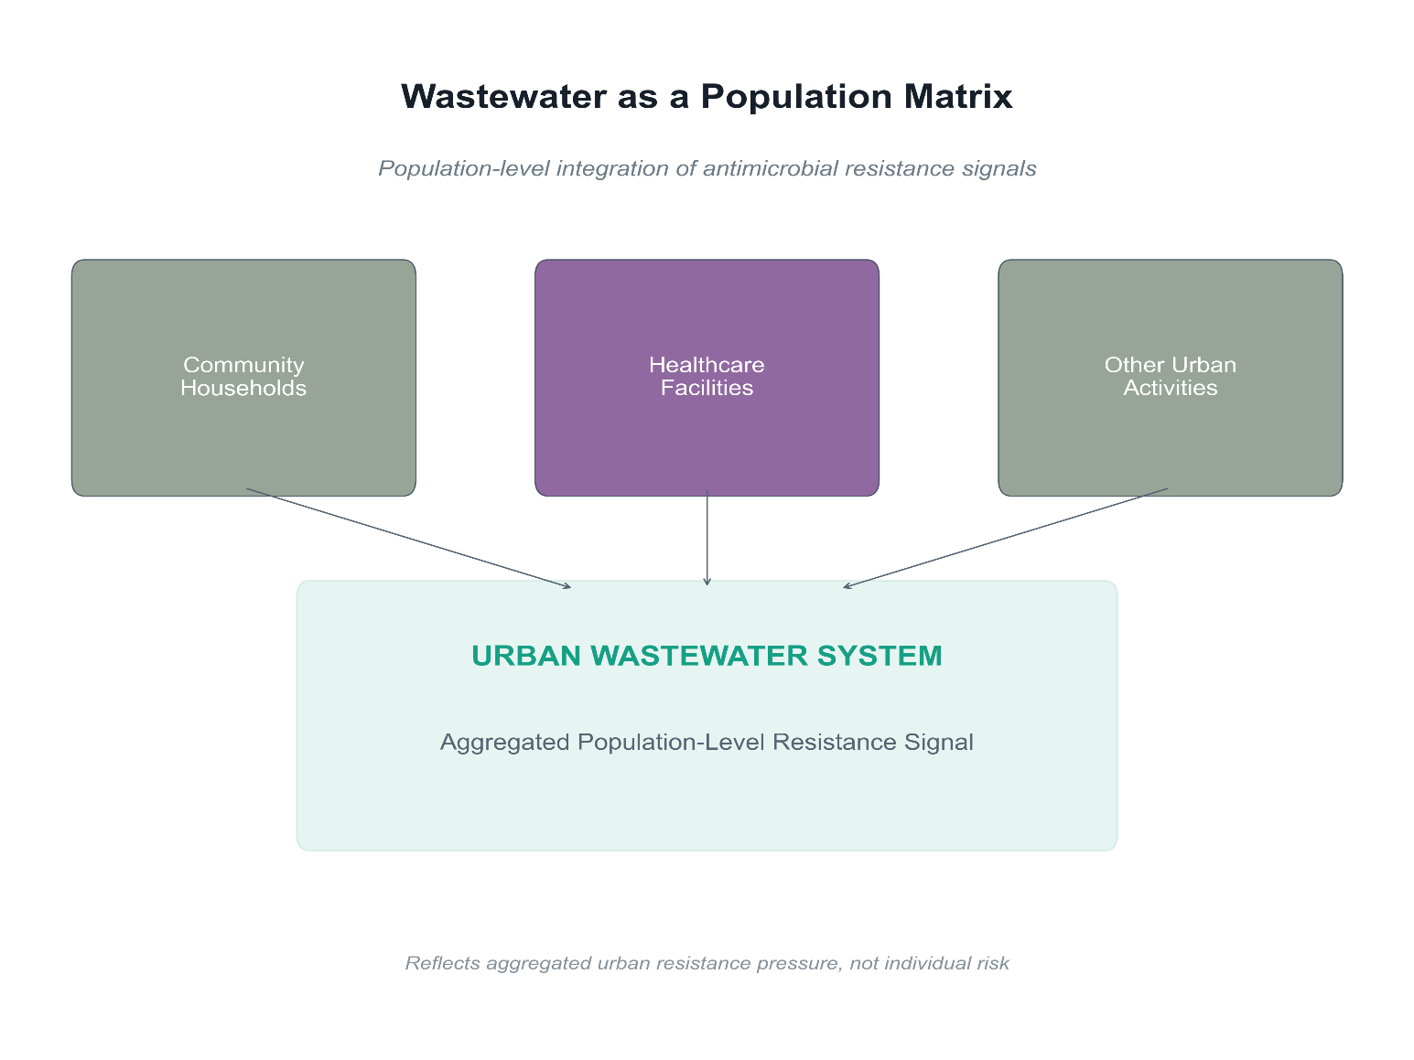
Research Questions
- How do antimicrobial resistance gene profiles differ between medical-influenced and non-medical urban wastewater in Tier-2 Indian cities?
- Which resistance classes and mechanisms are most prominently associated with medical waste influence at the population level?
- How can wastewater-based AMR data from underrepresented urban settings be interpreted responsibly within a One Health framework?
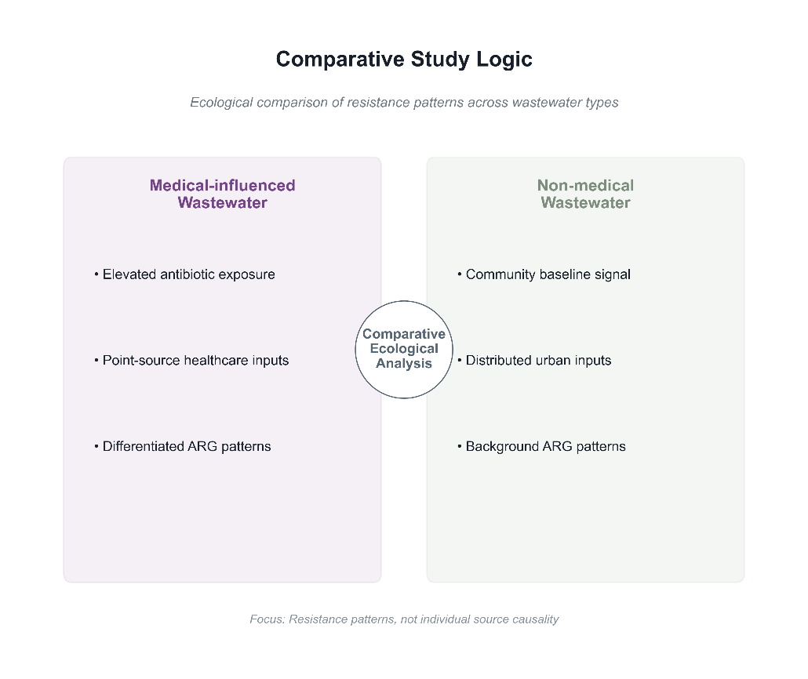
Objectives
- To perform a comparative metagenomic analysis of antimicrobial resistance profiles in medical-influenced and non-medical wastewater using public datasets.
- To identify dominant resistance classes and mechanisms associated with medical waste inputs.
- To develop a reproducible analytical and visualization framework for responsible wastewater-based AMR interpretation.
- To contextualize findings within a One Health framework without clinical or causal inference.
Scope
- Secondary analysis of publicly available, anonymized wastewater metagenomic datasets: Chosen to ensure ethical compliance, reproducibility, and feasibility, while focusing on population-level AMR signals rather than individual-level data.
- ARG aggregation at class and mechanism levels: Aggregation improves cross-study comparability, reduces annotation noise, and supports ecological rather than clinical interpretation.
- Comparative and multivariate bioinformatics analyses: Used to identify population-level differences between medical-influenced and non-medical wastewater without implying causality.
- Interpretation-focused visualization: Visual outputs are designed to communicate valid conclusions clearly while preventing clinical or predictive overreach.

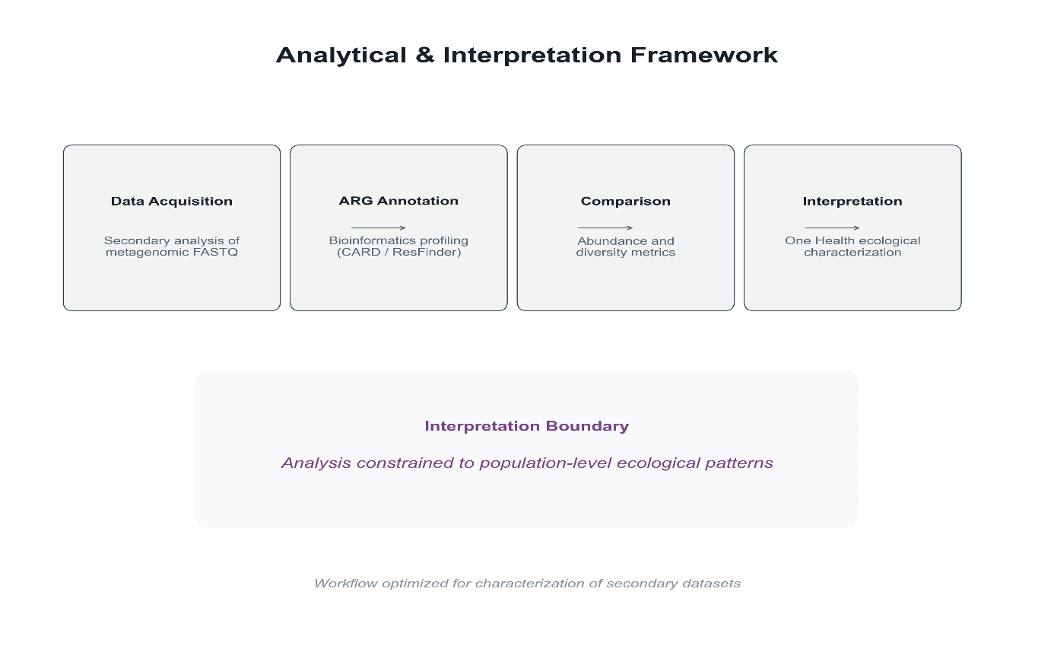
Methodology
- Data Source and Study Design:

- The study adopts an analysis-first, comparative design using publicly available, anonymized wastewater metagenomic datasets representative of Tier-2 urban settings in India. Datasets are retrieved from the NCBI Sequence Read Archive (SRA) and European Nucleotide Archive (ENA) using structured keyword queries targeting hospital wastewater, municipal wastewater, and urban sewage from Indian sites. Datasets are categorized into two analytical groups based on metadata annotation:
- Medical-influenced wastewater: Hospital effluent, healthcare facility drainage, or wastewater explicitly co-mingled with medical waste streams.
- Non-medical (community) wastewater: Municipal sewage, residential catchments, or urban wastewater without documented healthcare inputs.
- Dataset selection criteria include: (1) paired-end Illumina sequencing with minimum depth of 1 million reads, (2) availability of geographic and source metadata, and (3) absence of pre-processing that would remove resistance-relevant sequences. No wet-lab experimentation or sample collection is performed.

- Data Acquisition and Preprocessing :

- Sequencing run accessions (SRR/ERR identifiers) are retrieved from public repositories using the SRA Toolkit (version 3.0+). Raw reads are downloaded in FASTQ format using fasterq-dump with split-files mode enabled for paired-end data.

- Quality Control Pipeline:
  - Initial QC assessment: FastQC (v0.12+) is used to evaluate per-base quality scores, adapter content, GC distribution, and sequence duplication levels.
  - Read trimming and filtering: Trimmomatic (v0.39) or fastp (v0.23+) is applied with the following parameters:
  - Sliding window quality threshold: Q20 over 4-base window
  - Minimum read length: 50 bp
  - Adapter removal: Illumina TruSeq adapters
  - Post-QC validation: FastQC is re-run on trimmed reads to confirm improvement in quality metrics.
  - Low-quality runs (>30% reads failing QC) are excluded from downstream analysis.

- Taxonomic and ARG Profiling:
To provide ecological context, cleaned reads undergo taxonomic classification using Kraken2 (v2.1+) with the Standard database (RefSeq bacterial, archaeal, and viral genomes). Relative taxonomic abundances are estimated using Bracken (Bayesian Re-estimation of Abundance with KrakEN) at the genus and phylum levels.
- Taxonomic profiles are used to:
- Characterize microbial community structure across sample types
- Identify dominant taxa in medical vs. non-medical wastewater
- Contextualize ARG findings within host ecological backgrounds.

- Antimicrobial Resistance Gene (ARG) Profiling:

ARG detection is performed by aligning quality-filtered reads against curated resistance gene reference databases using ABRicate (v1.0+) or ShortBRED for short-read compatibility.

- Primary ARG Databases:
Database | Description | Use Case
CARD (Comprehensive Antibiotic Resistance Database) | Curated ARGs with resistance mechanism ontology | Primary detection and classification
ResFinder | Acquired resistance genes in bacteria | Validation of clinically relevant ARGs
MEGARes (v3.0) | Hierarchical ARG annotation (class → mechanism → group → gene) | Aggregation and comparative analysis

- Detection Parameters:
- Minimum identity threshold: ≥80%
- Minimum coverage threshold: ≥70%
- E-value cutoff: ≤1e-10

- Detected ARGs are aggregated at two levels:
- Antibiotic class level: Beta-lactams, aminoglycosides, tetracyclines, fluoroquinolones, macrolides, sulfonamides, etc.
- Resistance mechanism level: Antibiotic inactivation, efflux pumps, target alteration, target protection, target replacement.
Gene-level analysis is avoided to reduce annotation noise and prevent overinterpretation of individual gene variants.

- Normalization and Quantification:
To account for variable sequencing depth across samples, raw ARG counts are normalized using the following metrics:

- RPKM (Reads Per Kilobase per Million mapped reads): Adjusts for gene length and sequencing depth.
- Relative abundance: ARG counts expressed as proportion of total classified reads.
- Gene copies per 16S rRNA gene copy (if 16S data available): Provides cell-normalized abundance estimate.
Normalization enables valid cross-sample comparison regardless of original sequencing effort.

- Statistical and Comparative Analysis : All statistical analyses are performed in R (v4.3+) using the following packages:

- Descriptive Statistics:
- Mean, median, and interquartile range of ARG relative abundances per antibiotic class and mechanism
- Visualization using stacked bar plots, heatmaps, and boxplots (ggplot2, pheatmap)

- Multivariate Analysis:
Method | Purpose | R Package
PCA (Principal Component Analysis) | Dimensionality reduction; visualize sample separation | prcomp, factoextra
NMDS (Non-metric Multidimensional Scaling) | Ordination using Bray-Curtis dissimilarity | vegan::metaMDS
PERMANOVA | Test significance of group-level differences | vegan::adonis2
SIMPER | Identify ARGs driving group dissimilarity | vegan::simper

- Dissimilarity Metrics:
- Bray-Curtis dissimilarity: Default for abundance data
- Jaccard index: Presence/absence comparisons

- Statistical Thresholds:
- Significance level: α = 0.05
- Multiple testing correction: Benjamini-Hochberg FDR where applicable
.
- Interpretation Framework:

- Results are interpreted within a One Health framework emphasizing:
- Ecological selection pressures rather than clinical outcomes
- Comparative patterns between wastewater types
- Population-level signals without individual or source attribution

- Explicit Analytical Boundaries:
- No causal inference linking ARG presence to clinical infections
- No transmission pathway modelling
- No risk quantification or disease burden estimation
- No ranking or stigmatization of specific locations or institutions

IT Component: Analytical and Visualization Framework:
A reproducible bioinformatics and visualization framework is developed using:
- Pipeline Orchestration:
- Python (v3.10+): Data wrangling, API interactions, pipeline coordination
- R (v4.3+): Statistical analysis and publication-quality visualization
- Snakemake or shell scripts: Workflow automation for reproducibility

- Visualization Outputs:
Visualization | Purpose
Stacked bar charts | ARG class distribution per sample type
Heatmaps | ARG mechanism abundance with hierarchical clustering
PCA/NMDS ordination plots | Sample separation by wastewater type
Boxplots with significance annotations | Class-level abundance comparisons

- Reproducibility Measures:
- Version-controlled code repository (Git)
- Documented software versions and parameters
- Containerized environment (optional: Docker/Conda)
- Structured output directories with timestamped logs
The framework is designed for transparent analysis and responsible reporting, not real-time surveillance.

Limitations
- Wet-lab experimentation or sample collection: Excluded to maintain an analysis-first design and avoid laboratory and sampling variability.
- Clinical outcome or disease burden estimation: Wastewater data do not directly represent clinical infections; excluding this prevents overinterpretation.
- Source attribution or transmission inference: Mixed urban wastewater does not support reliable tracing to specific sources or pathways.
- Ranking of cities, hospitals, or regions: Comparative results are descriptive, avoiding stigmatization or policy misuse.
Expected Outcomes
- Comparative AMR profiles: Population-level comparison of antimicrobial resistance gene classes and mechanisms in medical-influenced versus non-medical wastewater from Tier-2 Indian cities.
- Reproducible analytical and visualization framework: A documented bioinformatics pipeline and interpretation-focused visualization system enabling transparent, responsible analysis of wastewater-based AMR data.
- One Health–aligned interpretation: Ecologically grounded interpretation of wastewater AMR patterns that informs environmental AMR understanding without clinical, causal, or surveillance claims.
Significance of the Study
This study addresses a critical gap in environmental AMR surveillance in Tier-2 Indian cities. By integrating bioinformatics, One Health principles, and interpretive discipline, it contributes both empirical insights and methodological guidance. The work supports national and global AMR strategies by demonstrating how wastewater data can be analysed responsibly without overstating public health implications.
References:
- One health joint plan of action (‎2022‒2026)‎: Working together for the health of humans, animals, plants and the environment. (n.d.). Retrieved January 21, 2026, from https://www.who.int/publications/i/item/9789240059139
- Programme, U. N. E. (2023). Bracing for Superbugs: Strengthening Environmental Action in the One Health Response to Antimicrobial Resistance. https://wedocs.unep.org/handle/20.500.11822/38444

